Wireshark Lab: DNS

Domain Name System (DNS) translates hostnames to IP addresses, fulfilling a critical role in the Internet infrastructure. In this lab, we’ll take a closer look at the client side of DNS. Recall that the client’s role in the DNS is relatively simple – a client sends a query to its local DNS server, and receives a response back. Much can go on “under the covers,” invisible to the DNS clients, as the hierarchical DNS servers communicate with each other to either recursively or iteratively resolve the client’s DNS query. From the DNS client’s standpoint, however, the protocol is quite simple – a query is formulated to the local DNS server and a response is received from that server.

nslookup

The syntax is:

nslookup –option1 –option2 host-to-find dns-server

In general, nslookup can be run with zero, one, two or more options. And as we have seen in the above examples, the dns-server is optional as well; if it is not supplied, the query is sent to the default local DNS server.

Do the following (and write down the results):

  - Run nslookup to obtain the IP address of a Web server in Asia.
  - Run nslookup to determine the authoritative DNS servers for a university in Europe.
  - Run nslookup so that one of the DNS servers obtained in Question 2 is queried for the mail servers for Yahoo! mail.

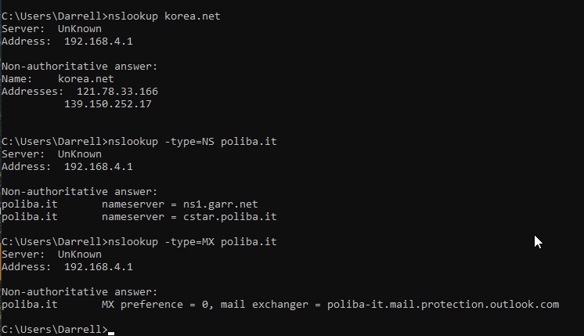

ipconfig

ipconfig \all

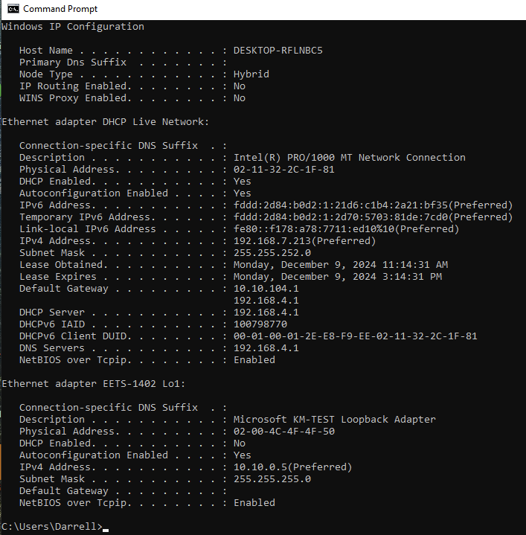

Tracing DNS with Wireshark

Now that we are familiar with nslookup and ipconfig, we’re ready to get down to some serious business. Let’s first capture the DNS packets that are generated by ordinary Web- surfing activity.

If you are unable to run Wireshark on a live network connection, you can download a packet trace file that was captured while following the steps above you can do so at the footnote.1. Answer the following questions:

- Locate the DNS query and response messages. Are they sent over UDP or TCP?
    - UDP
- What is the destination port for the DNS query message? What is the source port of DNS response message?
    - 53
    - 3163
- To what IP address is the DNS query message sent? Use ipconfig to determine the IP address of your local DNS server. Are these two IP addresses the same?
    - 128.238.29.23
    - Yes
- Examine the DNS query message. What “Type” of DNS query is it? Does the query message contain any “answers”?
    - Standard
    - No
- Examine the DNS response message. How many “answers” are provided? What does each of these answers contain?
    - 2
    - Type; Class; Address
- Consider the subsequent TCP SYN packet sent by your host. Does the destination IP address of the SYN packet correspond to any of the IP addresses provided in the DNS response message?
    - Yes
- This web page contains images. Before retrieving each image, does your host issue new DNS queries?
    - No
==============================================================================
2 Use the trace file dns-ethereal-trace-2
Now let’s play with nslookup2.

- Start packet capture.
- Do an nslookup on www.mit.edu
- Stop packet capture.

We see that nslookup actually sent three DNS queries and received three DNS responses. For the purpose of this assignment, in answering the following questions, ignore the first two sets of queries/responses, as they are specific to nslookup and are not normally generated by standard Internet applications. You should instead focus on the last query and response messages.

- What is the destination port for the DNS query message? What is the source port of DNS response message?
    - 53
    - 3742
- To what IP address is the DNS query message sent? Is this the IP address of your default local DNS server?
    - 128.238.29.22
    - Yes
- Examine the DNS query message. What “Type” of DNS query is it? Does the query message contain any “answers”?
    - Type A Standard
    - No
- Examine the DNS response message. How many “answers” are provided? What does each of these answers contain?
    - 7
    - Type A, Type NS / Type; Class; NS or IP.
- Provide a screenshot.
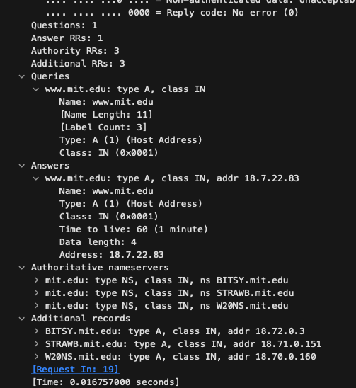

=================================================================
3 Use the trace file dns-ethereal-trace-3
Now repeat the previous experiment, but instead issue the command:

nslookup –type=NS mit.edu

Answer the following questions3 :

- To what IP address is the DNS query message sent? Is this the IP address of your default local DNS server?
    - 138.238.29.22
    - Yes
- Examine the DNS query message. What “Type” of DNS query is it? Does the query message contain any “answers”?
    - PTR
    - No
- Examine the DNS response message. What MIT name servers does the response message provide? Does this response message also provide the IP addresses of the MIT name servers?
    - mit.edu / bitsy.mit.edu / strawb.mit.edu / w20ns.mit.edu
    - The NS records do not provide IP’s, the “A” Pointer records do have IP’s.
- Provide a screenshot.
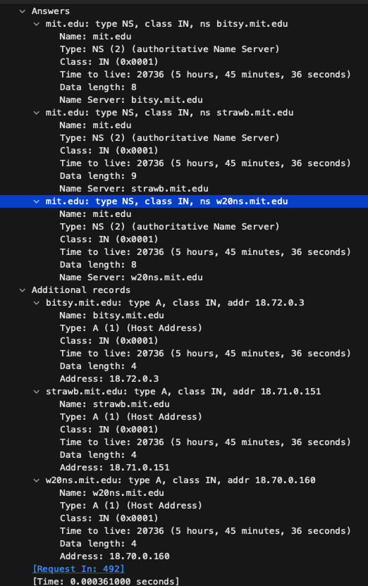
=================================================================
4 If you are unable to run Wireshark and capture a trace file, use the trace file dns-ethereal-trace-4
hhNow repeat the previous experiment, but instead issue the command:

nslookup www.aiit.or.kr bitsy.mit.edu

Answer the following questions4:

- To what IP address is the DNS query message sent? Is this the IP address of your default local DNS server? If not, what does the IP address correspond to?
    - 18.72.0.3
    - No.
    - A Reverse lookup was done and a PTR record was used to send the DNS query to. I’m not sure why?
- Examine the DNS query message. What “Type” of DNS query is it? Does the query message contain any “answers”?
    - PTR
    - No
- Examine the DNS response message. How many “answers” are provided? What does each of these answers contain?
    - 5
    - Type; Class; and either a fqdn or an IP.
- Provide a screenshot.
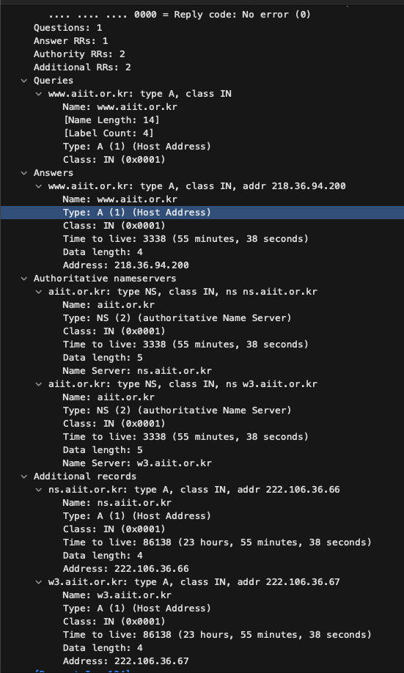
=============================================
Lab Report

Write a minimum of two type-written pages with a minimum of 12-point font describing what you learned in the lab. Do NOT simply repeat the steps you performed, summarize the purpose of the lab by explaining the concepts covered.

Be sure you write your report in your own words. If you don’t, I will know it and you will receive zero points for the lab and face possible other consequences. Although you may work with other to compete the lab procedure, your report MUST be your original work.

This lab required me to spend a good deal of time looking at both DNS requests but also DNS responses. There was a focused effort on getting me to recognize the types of DNS records and the origin of these responses. I was also provided the tools to lookup and verify various DNS sources.

I still have research to do to understand why pointer “A” records look different and why would an “A” record be the result of a DNS lookup as opposed to a NS record.

DNS is a double-edged sword. There is shock that these targets are so easily identified and at the same time they must be easily accessed for the internet as we know it to work.

I can remember 20 years ago when I was doing Pen Testing and one of the first tests I would do is identify the company DNS server and then try to do an anonymous ftp login. If I recall correctly this was the default setting on Linux version 7 and 8 servers and it had to be disabled, or a password added to secure it. I was always shocked when I was able to do a complete zone transfer and capture the entire network map of a large bank or business.

In the military we focused on certificates for security and CRL was a unique server that I had to install outside of the DMZ so that updated security certificates could easily be obtained. (either new adds or deletions). In this case I connected one CRL server to many DNS servers for updates.

DNS is far more interesting to me than most network “server” activities since it really is the first line of defense with certificates and secure connections but it also allows us to configure fun things like honeypots and false destinations so we can observe otherwise destructive activity. Using VM’s it is pretty easy today to setup a mouth watering network for attackers to play in.

My head is going to explode. I have ADD and have a difficult time keeping my focus on the things that are important. I want to be an expert in too many things. Software Dev, Firewalls and IDS, Routing and Switching, Network Architecture in terms of setting up domains and the server infrastructure, and on and on…. I have to learn to limit my focus.

DNS could easily be a rabbit hole for me – but I have to resist.

